Topic: Environment.
1. Read the text and answer the questions bellow.

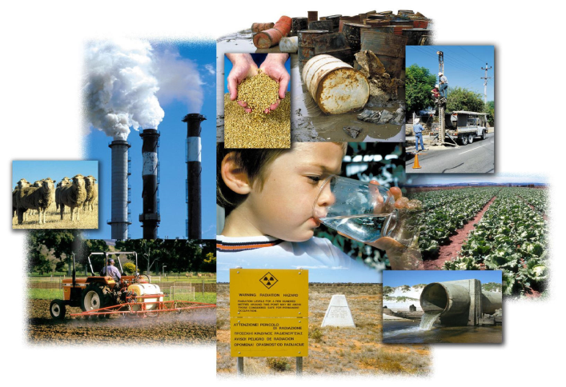
Environmental problems is the most burning problem of today. The ecological problem influence the climate on the Earth. Mankind long believed that, whatever we did, the Earth would remind much the same. Nature is under threat. Our country’s pollution can be every country’s problem. So we all need to work together to safeguard our environment.
Air pollution is a very serious problem. Industrial enterprises emit tons of harmful substances. They are the main reason for the greenhouse effect and acid rains. The pollution of air and the world’s ocean, destruction of the ozone layer is the result of man’s careless interaction- with nature a sign of the ecological crises. Rains, full of acid chemicals, change lakes, rivers, as well as forests. Acid water kills the plants and animals that usually live in water. Acid rain makes the Earth more acidic and some kinds of trees can’t live in the sol that is very acidic. Forests are disappearing and this upsets the oxygen balance. Water pollution occurs mostly, when people overload the water environment such as streams, lakes, underground water, bays or seas with wastes or substances harmful to living being.
Nuclear weapon is also course of the pollution. It brings a great damage to the agriculture, forests and people’s health.
The greenhouse effect and global warming both correspond with each other. The greenhouse effect is recalled as incoming solar radiation that passes through the Earth’s atmosphere but prevents much of the outgoing infrared radiation from escaping into outer space. It causes the overheat of the air as a result we have the global warming effect.
People are beginning to realize that environmental problems are not somebody else’s. In many countries environmental protection agencies and research centers are up. Such organization as “Green Peace” cares for ecology in countries. Its main goal is to combine the people’s efforts for peace with the huge and ever mounting movement launches all kind of environmental actions and inform of the ways, means and results of this work.
a) Fill in the table.
Ecological
problems

b) True / False
- Environmental problem isn’t the most burning problem of today. (False)
- We all shouldn’t work together to safeguard our environment. (False)
- Nuclear weapons are also course of the pollution. (True)
- People are beginning to realize that environmental problems are somebody else’s. (False)
- Such organization as “Green Peace” cares for economy in countries. (False)

2. Put in the necessary words from the column.
Environmental, threaten, pollution, concerned , recycling, proof, organization, production, helpful, global.

There are many problems which (1) ___________ our natural environment. Acid rain, (2) __________ warming and air and water (3) ___________ are among the most serious ones. There are several ways to help improve the situation. Firstly, we should encourage (4) _______
Because it is the (5) ________ of new materials which causes the most damage. We must learn to reuse things like plastic bags and glass jars. Secondly, driving an environmentally-friendly car is also (6) ________.
Furthermore, joining an (7) _________ which plants trees or cleans up beaches would be a (8 ) ____________ that you are really (9) _________ about the environment. Lastly, supporting groups such as Greenpeace, which try to prevent many (10) _________ disasters, would help to ensure that our planet will be clean and safe for the future generations.

3. Write the following sentences using Present Perfect Passive Voice.

- Teenagers have broken a lot of trees.
- Factories and plants have polluted our rivers.
- Bob has written the words “I love Helen” on the tree.
- These children have dropped a lot of litter in the forest.
- The pupils of 9 «A» class have collected 30 kilogram’s of wastepaper.

4. Choose the right variant.
1. The environment is a very important thing … humans.
a) to b) for c) in d) of
2. Environmental problems will get worse and worse until we … pollution.
a) stop b) stopped c) will stop d) has stopped
3. By the time we … how to recycle, it might be to late.
a) learn b) will learn c) have learned d) learned
4. Our river will be polluted until we … do something for cleaning it.
a) start b) will start c) have started d) started
5. Serious pollution … chemicals and waste made by factories.
a) cause b) is caused by c) affect d) is affected by
6. Ninety-three per cent of Jamaica’s coral reefs … .
a) destroy b) have destroyed c) have been destroyed d) destroyed
7. Polluted air and water … people’s health.
a) threat b) reduce c) litter d) damage
8. I suggest starting a programme to stop industries from using poisonous … .
a) chemicals b) litter c) garbage d) rubbish
9. Some gases that … air can dissolve in water and in the atmosphere.
a) litter b) waste c) pollute d) release
10. After the school party we had to clean the … .
a) rubbish b) waste c) litter d) poison
11. This pollution can be so harmful, that it can … the land, water and air.
a) affect b) effect c) cause d) harm
12. Many teenagers usually … litter near their school.
a) pour b) drop c) release d) affect
13. Environmental problems are caused by … humans.
a) a b) an c) the d) –
14. … water is one of the most important resources for life.
a) a b) an c) the d) –
15. A lot of animals live in …. seas, rivers and lakes.
a) a b) an c) the d) –

5. Match the words in the left column with their meaning in the right column.
1. soil  2. land  3. ground  4. earth | a) the land surface on which we live and move about  b) the soil and rocks on the earth’s surface  c) the substance on the surface of the earth in which plants grow  d) an area of ground that is used for a particular purpose such as farming or building

6. Write a letter to your pen-friend.

You have received a letter from your English- speaking pen-friend Ann who writes:
… More and more young people get involved in environmental protection. Could you tell me what measures young people in your country take to save the environment? What kind of support do you get from your local community and family? Is there any Green Party/Movement where you live? Wouldn’t you like to start one, if there isn’t?
I am very happy now because I have just passed my last exams.

Write back soon,
Ann

Write a letter to Ann.
In your letter
- answer her questions
- ask 3 questions about her plans for the coming holiday
Write 100-140 words.
Remember the rules of letter writing.

- Работы присылать Вк или на Gordoalena@yandex.ru
- ЗАДАНИЯ ВЫПОЛНЯЕМ И ПРИСЫЛАЕМ в день, когда у Вас лента по расписанию.

