Money
- Дорогие друзья! Данный материал рассчитан на 2 занятия.
- Part 1 – напишите слова по английский, их транскрипцию и перевод. (Занятие 1) нужно было выполнить до 30.04.20.
- Part 2 – переведите слова и их значение. (Занятие 2) ДО 08.05.2020

THE MAJOR CURRENCIES (part 1 )
$ = Dollar | € = Euro
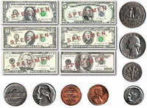 | 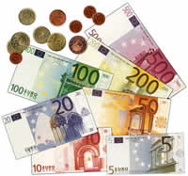
£ = Pound (Sterling) | ¥ = Yen
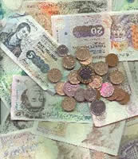 | 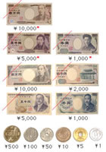

WAYS OF PAYING
 |  | 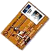
cash | cheque(s) | credit (slang - plastic)

GENERAL MONEY VOCABULARY
 | bank(s) | cash box(es) | cash machine(s) / ATM(s)
 |  | 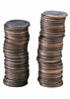
 | cheque book(s) | coin(s) | note(s)
 |  |  | 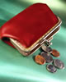
 | piggy bank(s) | poor | purse(s)
 | rich | safe(s) | till(s)
 |  | wallet(s)

account | n. a record of money a person deposits into a bank
ATM | n. Automatic Teller Machine aka Hole in the wall.
balance | n. the difference between credits and debits in an account
bank | n. a building in which commercial banking is transacted.
bank charges | n. money paid to a bank for the bank's services etc
banker's draft | n. a cheque drawn on the bank (or building society) itself against either a cash deposit or funds taken directly from your own bank account.
barter | v. to trade without using money.
borrow | v. to ask for the temporary use of money on the condition of repayment and at a set rate of interest.
branch | n. local office or bureau of a bank
building society | n. A building society is like a bank, but it is owned by its members - savers and borrowers - and not by shareholders. Its traditional purpose was to lend money to individuals to purchase or remortgage their homes. This money used to come exclusively from individual saving members who are paid interest on their deposits. Now, an increasing proportion, but still a minority of the funds are raised on the commercial money markets.
cashflow | n. cash earnings minus cash outflows for fixed- and working-capital investment.
cashier | n. an employee of a bank or building society who receives and pays out money.
chequebook | n. book containing detachable cheques
cheque | n. written order to a bank to pay the stated sum from one's account
counterfeit | n. fake money made in order to deceive - also v.
credit | n. money in a bank a/c; sum added to a bank a/c; money lent by a bank - also v.
credit card | n. (plastic) card from a bank authorising the purchasing of goods on credit
currency | n. money that is used by a country such as the United Kingdom.
current account | n. bank a/c from which money may be drawn at any time; checking account US
debit | n. a sum deducted from a bank account, as for a cheque - also v.
debit card | n. you use a debit card in much the same way as a credit card but instead of receiving credit after making your purchase, the funds are automatically (within a few days usually) withdrawn from your bank account.
debt | n. the state of owing something (especially money).
denomination | n. a number that expresses the value of a coin or bill. A five pound note and a ten pound note represent two denominations.
deposit | n. an amount of money placed with a bank
deposit account | n. bank a/c on which interest is paid; savings account US.
fill in | v. to add written information to a document to make it complete.
foreign exchange | n. Used to describe the currency of other countries and the system for dealing in such currency (often shortened to Forex).
interest | n. money paid for borrowing money, or money that a bank or building society pays a customer for putting money into their bank.
interest rate | n. the percentage of an amount of money which is paid for the use of that money over a period of time.
lend | v. to give the temporary use of money on the condition of repayment and at a set rate of interest.
loan | n. money lent by a bank etc and that must be repaid with interest - also v.
mortgage | n. most of us do not buy our homes outright for cash - instead we borrow money to do so.
overdraft | n. deficit in a bank account caused by withdrawing more money than is paid in
pay | v. To give (someone) money that is due for work done, goods received, or a debt incurred.
pay | n. Money paid to someone for regular work. Also see salary.
pay in | v. to deposit or put money in to a bank account
payee | n. person to whom money is paid
paying-in slip | n. small document recording money that you pay in to a bank account
pence | n. more than one penny.
pension | n. A regular payment made during a person's retirement (when they become too old to work) from an investment fund to which that person or their employer has contributed.
salary | n. A fixed regular payment, typically paid on a monthly or biweekly basis made by an employer to an employee.
standing order | n. an instruction to a bank to make regular payments
statement | n. a record of transactions in a bank account
withdraw | v. to take money out of a bank account
withdrawal | n. the act of taking out money.

