Тема: Исчисляемые и неисчисляемые существительные.
- Перепишите правило (все таблички).
- Посмотрите видео по ссылке https://youtu.be/DLhuS6V7gbY
- Выполните упражнения 1,2 в тетради. Подпишите каждую страницу. Не забудьте поставить число.
- Электронный адрес: yliy.bipert1982g@mail.ru
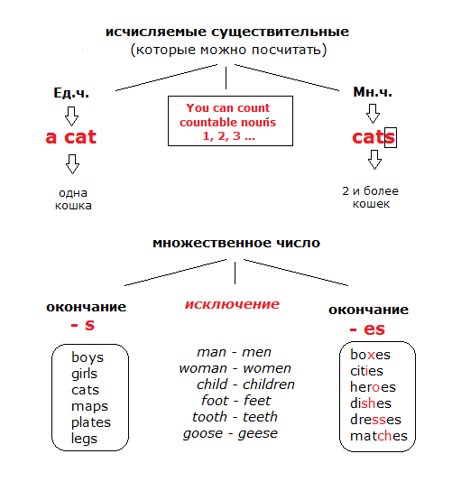

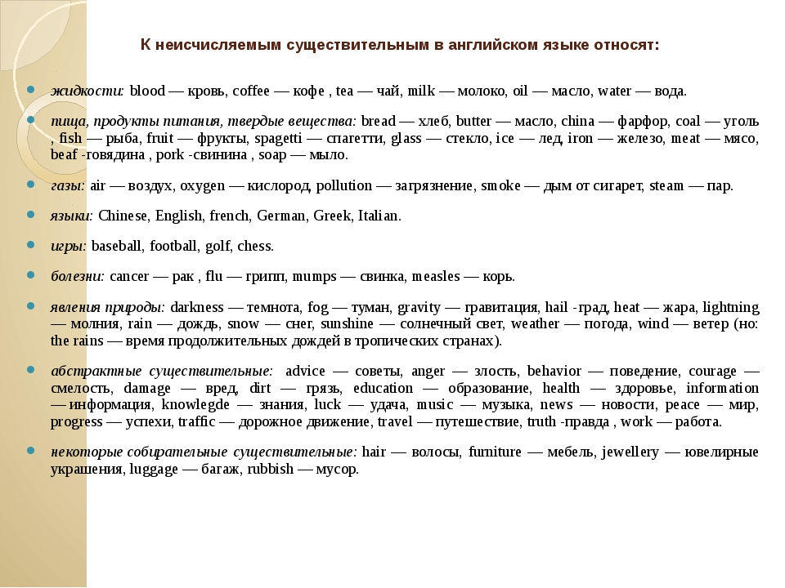

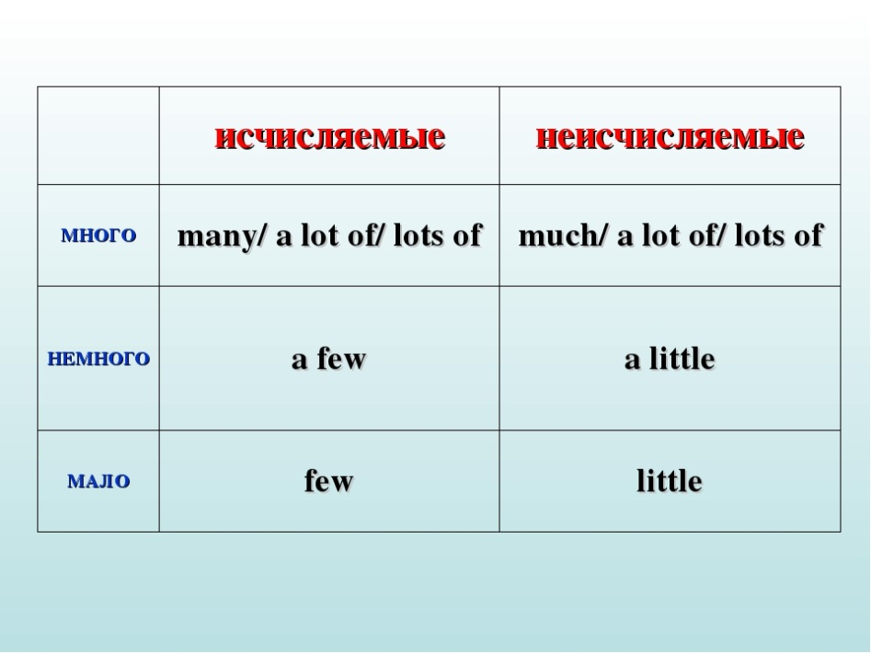
Заполните пропуски и перепишите в тетрадь
1. Fill in the gaps with much, a little, little, many, a few, few.
1. There are...........boys in our group and.............girls.
2. We are thirsty! - It's a problem! There is ...........water.
3. There is ...........cheese in the fridge. It's not enough for the salad.
4. There are...........people at the stadium. - Because it has been raining all day.
5. There isn't...........snow in the yard.
6. There is ...........food in the kitchen. We can't feed our guests.
7. This disc has only...........good songs. I don't want to buy it.
8. My younger brother likes to go to the kindergarten. There are...........toys there.
9. There is ...........furniture in my parents' bedroom: a bed, built-in wardrobe and two bedside tables.
10. I want to knit a short jacket. I don't need...........wool yarn for it.

2 Fill in the gaps with much, a little, little, many, a few, few.
1. I like my coffee with...........milk and sugar.
2. The meal costs...........euros.
3. You look fit! Do you exercise...........?
4. There is only...........gouache in the bottle. You can't draw any pictures.
5. Don't talk too...........at the lesson.
6. We know the material well and ask the teacher only...........questions.
7. There are...........nuts in the bowl, put some more, please.
8. I don't like sweet tea, so I put only...........sugar in my tea.
9. They have...........money. - Are you sure they are poor?
10. In our country we don't eat...........seafood.

