Специальный вопрос
SPECIAL QUESTION
- Study the grammar

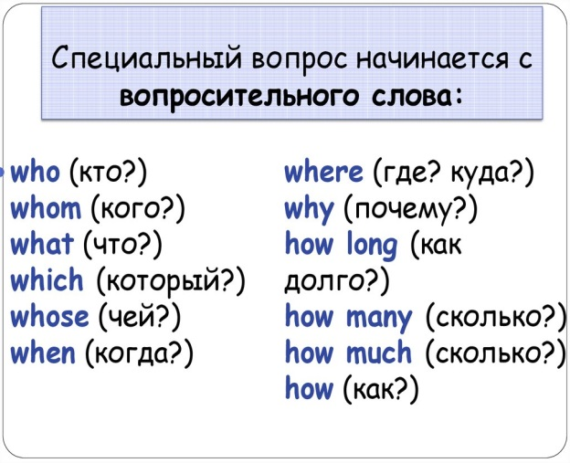
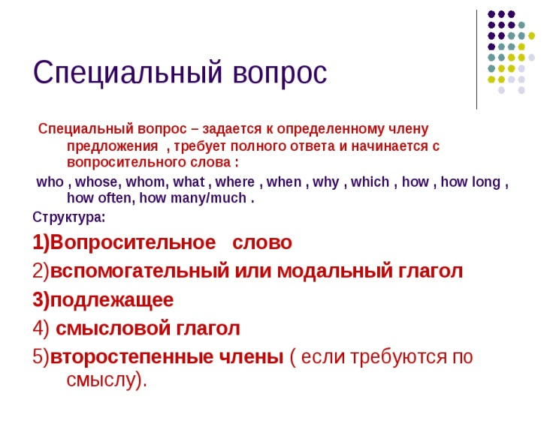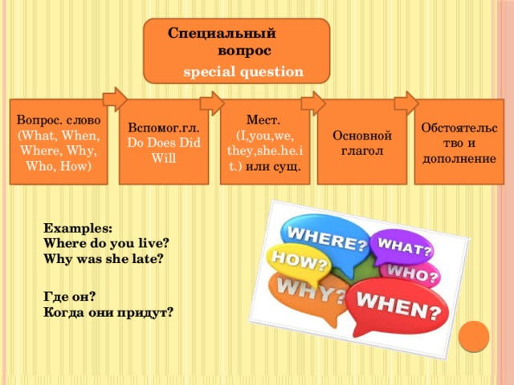

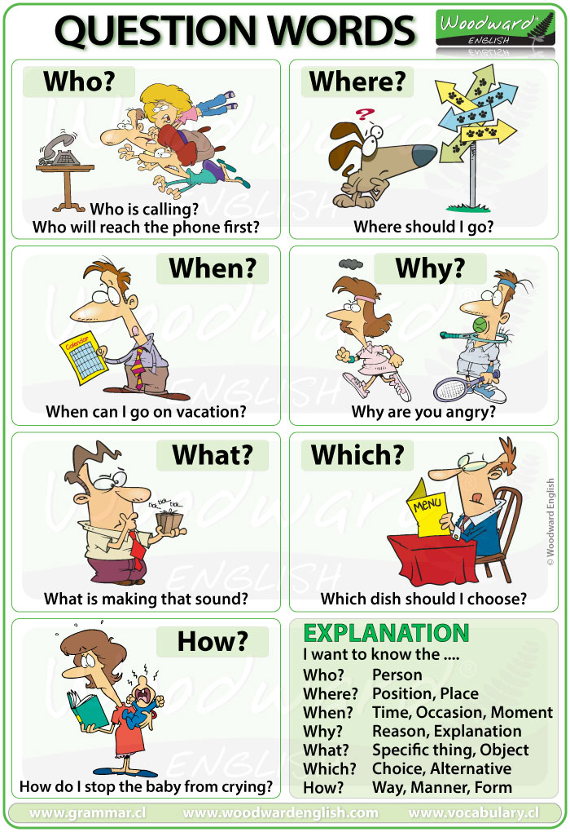

- Grammar practice
Task 1. Put questions to the words in the italics.
1. Kate likes to walk along the streets in good weather.
2. You need to turn to the right.
3. His father leaves his car in the street.
4. Alex has his English lessons three times a week.
5. He drives fast.
6. They drive on the right side of the road in that country.
7. We have several thousands books in our home library.
8. Peter's granny cooks very tasty dishes.
9. She is looking for a map to find that workshop.
10. A waiter brings the customers their desserts.

Task 2. Put the words in the right order.

1. when I start I competitions I your I do?
2. from I left I to get to I turn I Red Square
3. in I popular I kind I of transport I what I
4. she I does not I why I the hospital I take
5. he I does I play I football I how often?
6. rides I a motorbike I your I who I family
7. old I this I bridge I is I how?
8. lead I side I does I to where I this I street?
9. get off I at I third I stop I the train I the.
10. coming I give way I to cars I at crossroads I from the right.

Task 3. Answer the questions

- What is your name?
- How old are you?
- When`s your birthday?
- Where do you live?
- What `s your favourite hobby?
- What`s your surname?
- How do you spell your surname?
- What`s your email address?
- What`s your future profession?
- How long does it take to get to the technical school?

