Материал для дистанционного обучения

Переведите текст письменно

3. Результаты работы отправьте на электронную почту yulya.bipert@yandex.ru , Viber, WhatsApp, Telegram, VK

4. До 28.05.

Тема "Здоровое питание" (Healthy eating)

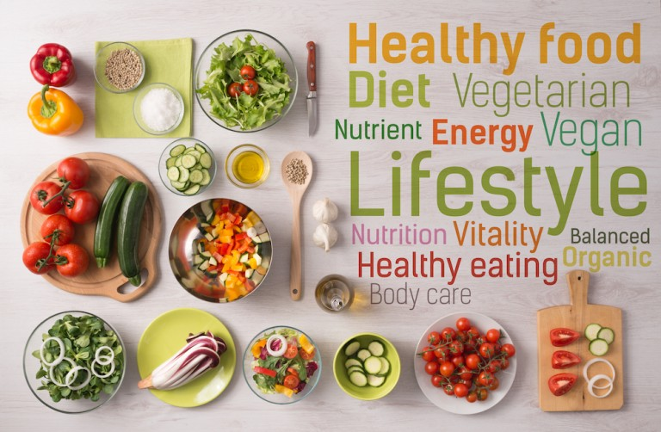
Our health depends on our eating. Food provides us with the energy that we spend with physical exertion. Update and development of the organism at the cellular level directly depends on the products that we use. The body needs to receive a sufficient number of nutrients every day: proteins, carbohydrates, fats, vitamins, minerals, trace elements.
Proper nutrition is a mandatory point of a healthy lifestyle and a guarantee of stable functioning of the body as a whole.
Everyday diet should be diverse and full. Freshness of products is very important. It is necessary to monitor the volume of food intake. Each person's portion varies, depending on age, health status, gender, and equipment. Cereals, fruits and vegetables, fish, meat, eggs, dairy products, nuts, salt, sugar, fat, should be present in the diet. A balanced diet should become a way of life. You should refuse to give up snacks and fast food. Thoroughly chew food, do not swallow large chunks. It is strictly forbidden to drink food with water. You can eat everything, but in moderation. Overeating and incompatibility of products leads to a disruption of metabolism, diabetes and obesity. It is very appropriate to say Socrates: "We do not live in order to eat, but eat in order to live."

