ЗАДАНИЯ ДЛЯ ДИСТАНЦИОННОГО ОБУЧЕНИЯ

- Учебник: Бескоровайная Г.Т Planet of English; учебник английского языка для учреждений СПО. М - 2017г (НА САЙТЕ ТЕХНИКУМА)
- Работы присылать на электронный адрес: yliy.bipert1982g@mail.ru
- Оформите свой ответ на задания в документе MS Word и отправьте на электронную почту
- Дата: до 15.04.20
Task 1. Read the text and answer the question: (устно)
Why do the British drive on the opposite side of the road? (письменно)
Why We Drive on the Left in the UK
The "rule of the road" in mainland Europe and the majority of countries in the world, including the United States, is "to drive on the right".
In the United Kingdom and some of her former dominions: Australia, New Zealand, Kenya, Zambia, South Africa, Zimbabwe, some Caribbean Islands including Barbados and St Lucia, India and Pakistan and the Mediterranean island of Malta, the rule of the road remains to drive on the left. This also applies in Japan and Thailand.
The origin of this rule dates back to how people travelled in feudal societies. As most people are right-handed, it made sense to carry any protective weapon in this hand. When passing a stranger on the road, it would be safer to walk on the I left, so ensuring that your weapon was between yourself and a possible opponent. Knights would hold their lances in their right hand, therefore passing on each others' left.
Revolutionary France changed this historic practice, as part of its social rethink. Their military general and Emperor Napoleon Bonaparte was left-handed, therefore his armies had to march on the right, so he could keep his sword arm between him and the advancing enemy. From that time any part of the world that was colonized by the French would travel on the right, and the rest would remain travelling on the left.
Task 2. Put questions to the words in the italics. (задайте вопросы к выделенным словам)(письменно)
1. Kate likes to walk along the streets in good weather.
2. You need to turn to the right.
3. His father leaves his car in the street.
4. Alex has his English lessons three times a week.
5. He drives fast.
6. They drive on the right side of the road in that country.
7. We have several thousands books in our home library.
8. Peter's granny cooks very tasty dishes.
9. She is looking for a map to find that workshop.
10. A waiter brings the customers their desserts.
Task 3. Put the words in the right order. (письменно)
1. when I start I competitions I your I do?
2. from I left I to get to I turn I Red Square
3. in I popular I kind I of transport I what I
4. she I does not I why I the hospital I take
5. he I does I play I football I how often?
6. rides I a motorbike I your I who I family
7. old I this I bridge I is I how?
8. lead I side I does I to where I this I street?
9. get off I at I third I stop I the train I the.
10. coming I give way I to cars I at crossroads I from the right.

Задания на дополнительную оценку

Тема. Местоимения
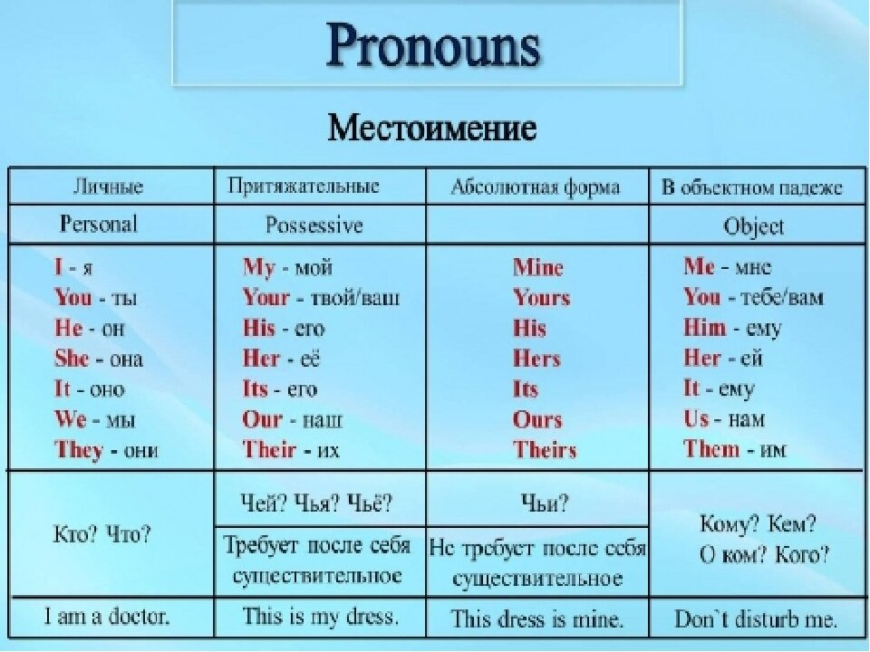

1. Напишите по-английски
моя книга______________________________________________________
ее ручка _______________________________________________________
наша комната __________________________________________________
его собака _____________________________________________________
ваш портфель__________________________________________________
их комната ____________________________________________________
твоя машина___________________________________________________
2. Переведите на английский язык следующие
предложения
l. Ta книга – не моя.______________________________________________
2. Эта книга – моя._______________________________________________
3. Это – моя книга, а то – его.______________________________________
4. Это ее карандаши, а те – мои. ____________________________________
5. Возьми те карандаши. __________________________________________
6. Я люблю такие ручки, они хорошие. ______________________________
7. Ваша ручка плохая, возьмите мою. ______________________________

3. Замените выделенные слова личными
местоимениями
1. Peter helped the pupils to translate the text. ______________________________
2. Mother asked Mary to wash the plates. __________________________________
3. My friend writes a letter to his sister.____________________________________
4. Jane took 3 books from the library (there). _______________________________
5. His cousins live in Moscow.____________________________________________
6. Our grandfather and grandmother will come tomorrow. ___________________
7. Mary works in a shop.________________________________________________
4. Переведите на русский язык
- This is a pen and that is a pencil.
- These are tables and those are chairs.
- This is a plate and that is a lamp.
- This is a bed and that is a sofa.
- This is a cap and that is a hat.
- This is my book and that is your copybook.
- This is my house and that is yours.
- That house is mine.

5. Употребите нужное возвратное местоимение
1. I shall ask him……….....
2. Не wants to do it………....
3. She washed………....
4.You will answer the letter………....
5. I looked at …………….... in the mirror.
6. We shall tell her………….……...
7. They have done the task............................
8. She doesn't like to speak about……………….....
9. The story……………... is very good, but not the translation.

